**What is solar power?**

Solar energy is a solution for our increasing demands of energy. Energy from the sun can be converted into other useful forms of energy by direct or indirect method.

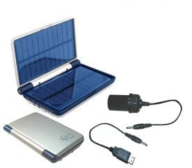

1. Direct method

It can be directly converted into electricity without using a long procedure.

2. Indirect method

The indirect method follows the production of electricity by the use of concentrated power. The concentrated solar power plants use many concentrating mirrors for the absorption of sun rays; this solar energy is then converted into high intensity heat energy which is then converted into electrical energy.

Qualities of solar power

Solar power is a good alternative source of non-renewable resource which is a prior option of people and a tremendous source of energy. This is a proficient and environment-friendly process which is in great demand but it is hard for people to acquire it for their needs. Not many processes can be used for inaccessible areas and electricity cannot be provided to these areas but portable solar system has made it possible. Gasses like carbon dioxide, carbon monoxide and other greenhouse gasses.

Portable solar systems

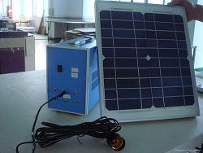

Going for camping, fishing or to a remote area for some kind of research? You need not worry. You can take all your techno-gadgets with you. They can be recharged easily with the help of these systems. The cleanable, elastic and bendable portable solar system has a panel of solar cells which are embedded together and provide energy to the consumer. A small solar energy plate can recharge small devices like camera, mobiles etc. while a large solar plate can recharge laptop, DVD player and other household appliances. The size and type of a solar panel depend on your requirement. The companies or small business can be employed to use the junction of compacted cells to serve their purpose.

Types of portable solar systems

They come in many types depending on their nature, cost, size and panels composition. The types are:

1. **Global solar system**: Its flexibility is enough that it can be taken anywhere and can be used to charge your laptop. Its cells do not damage. It is protected by strong nylon with urethane base. It is resistant to ultraviolet rays and any weather cannot damage it and you do not have to worry about the weather.

2. **Goal 0**: Its quality is its foldable nature and its weight. It fits perfectly your bag pack. It has a satisfactory amount of energy and can charge your electric device. Its advantage is that the excess power can be stored and used at night where so solar energy can be obtained on the spot. So it is perfect for outdoors.

3. **SUNLINQ**: This multipurpose portable device has a series of power to select from. It is protected and waterproof. It can also be taken to beach and also while swimming, camping and hiking because no sand, water or a UV ray can damage it. It is very flexible and a built in diode for current protection. It can also provide energy on a cloudy day.

Main benefits

The most important benefits are:

1. If you create more energy than required than the company will pay you.
2. It helps the environment.
3. The nation can become less dependent on imports of oil and other fuels.
4. They can provide help to anyone around the globe.
5. The fact that it is portable has an advantage that it can be taken anywhere with you.

from：<https://www.conserve-energy-future.com/portablesolarpower.php>